**Visualization**

**Clothes and Accessories:Sales_Product_Details.csv**

**DatasetId:DS279**

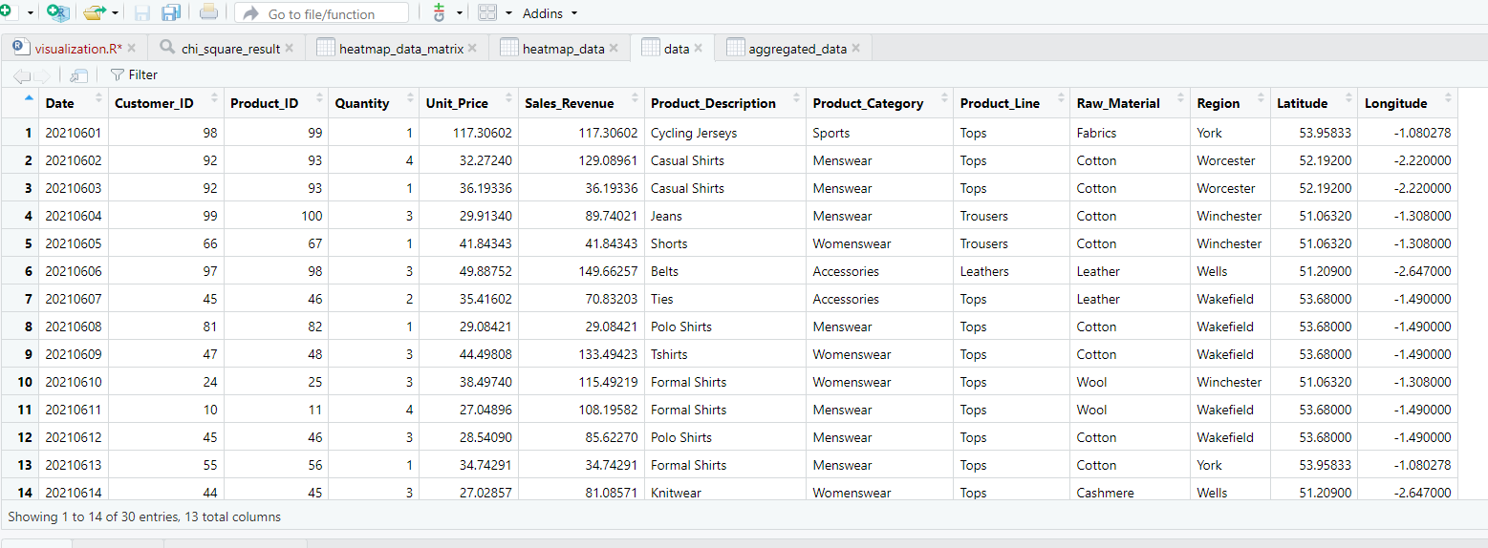

**Research question:**

Is there a difference in the proportions of sales revenue across different product categories in various region?

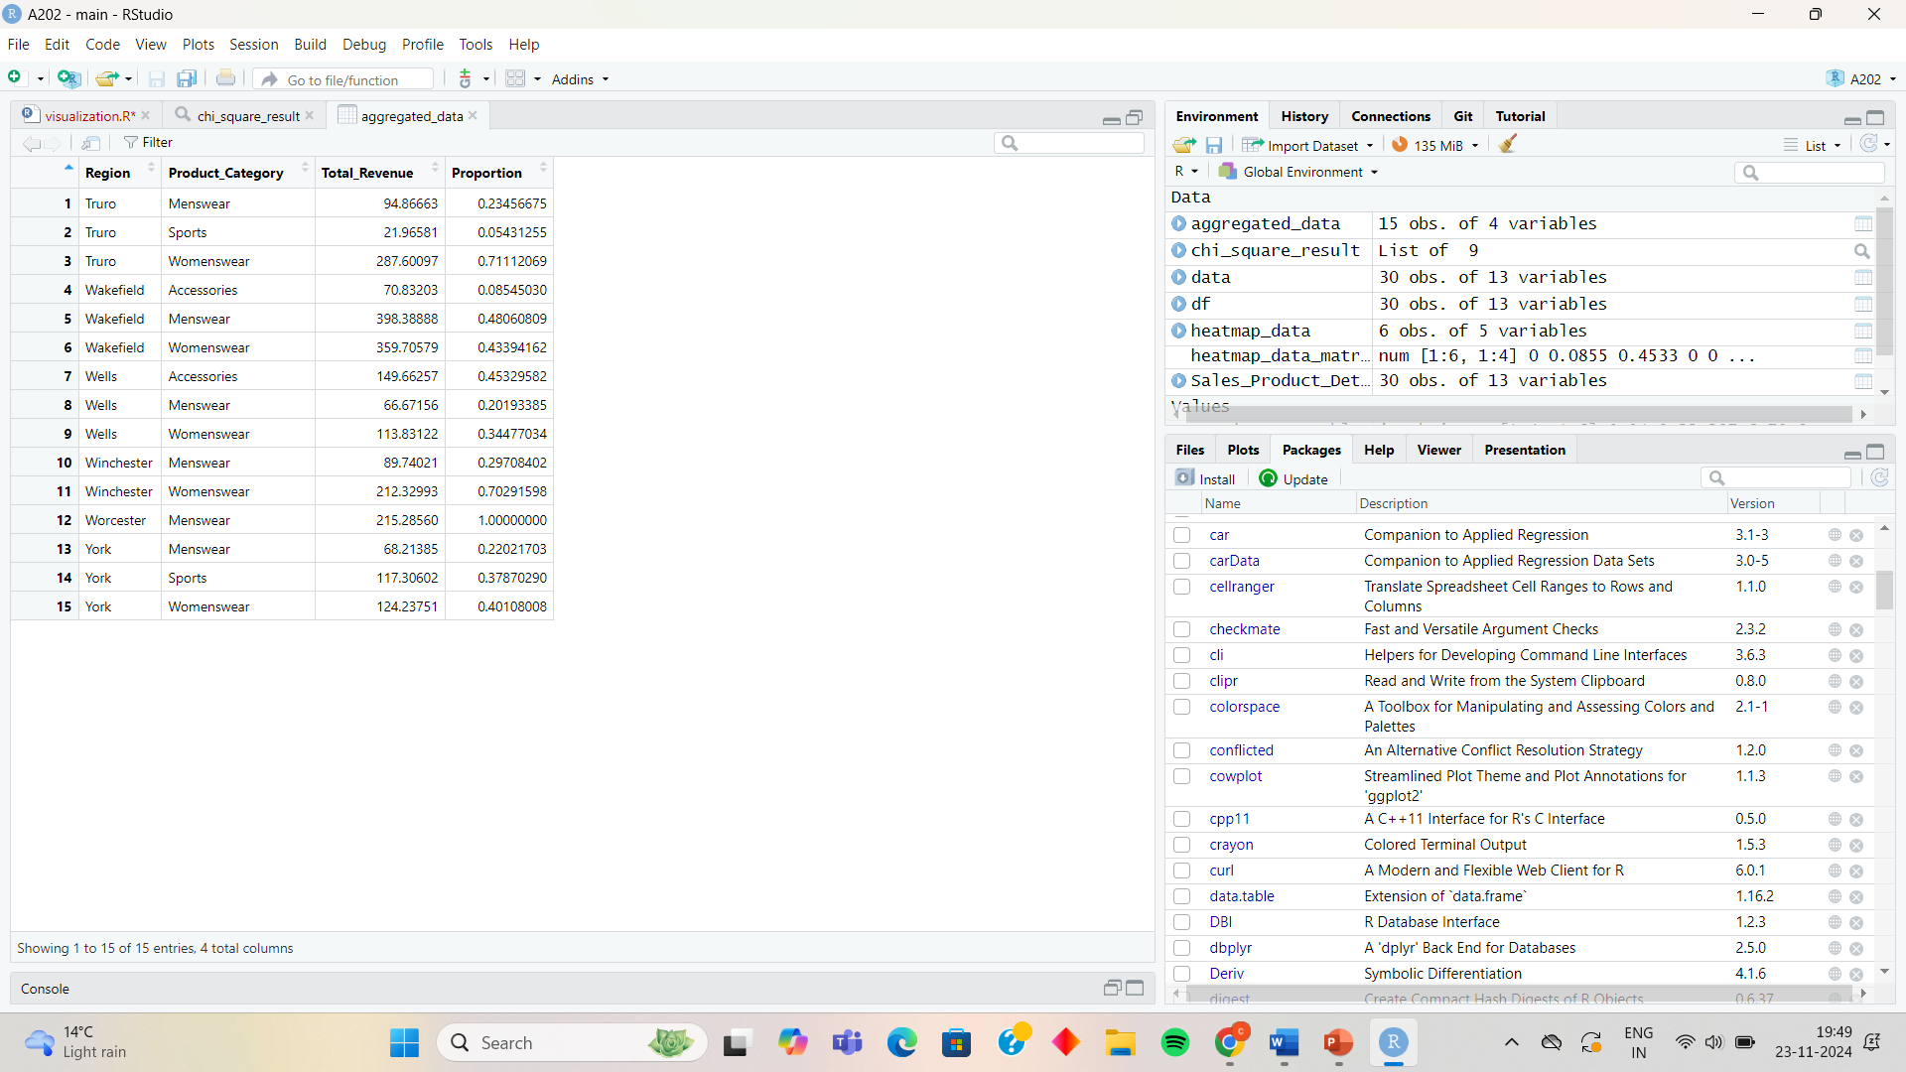

Stacked Barplots

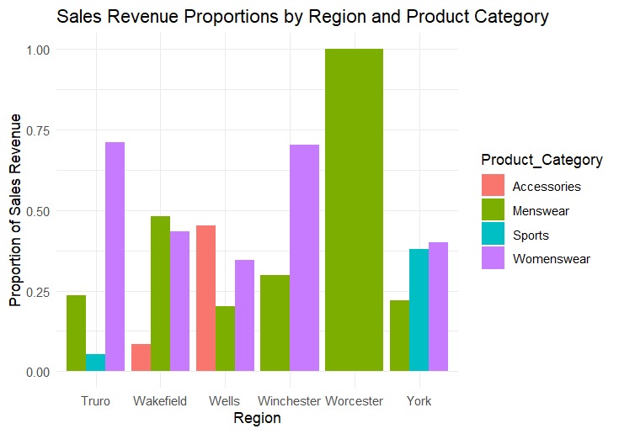

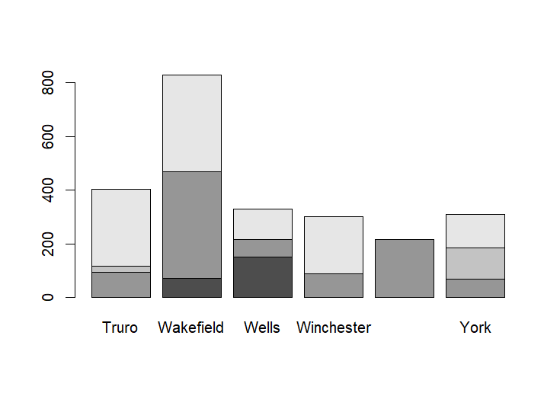

Chi_square_Test

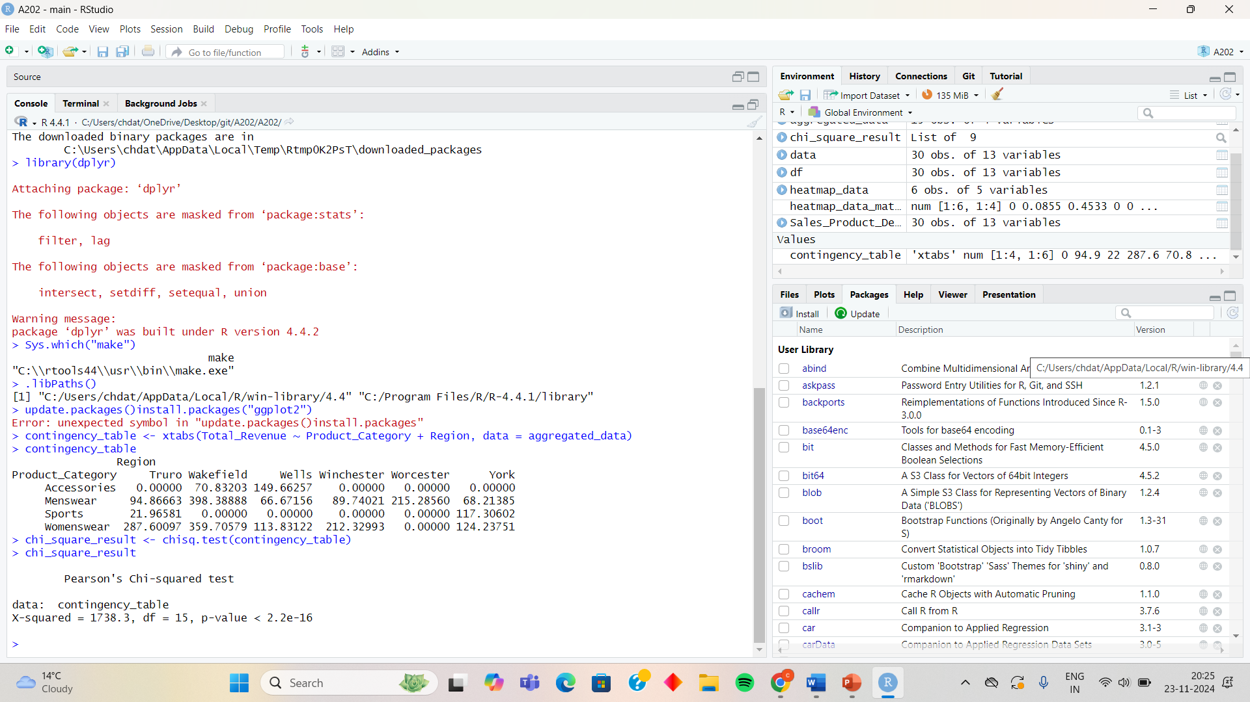

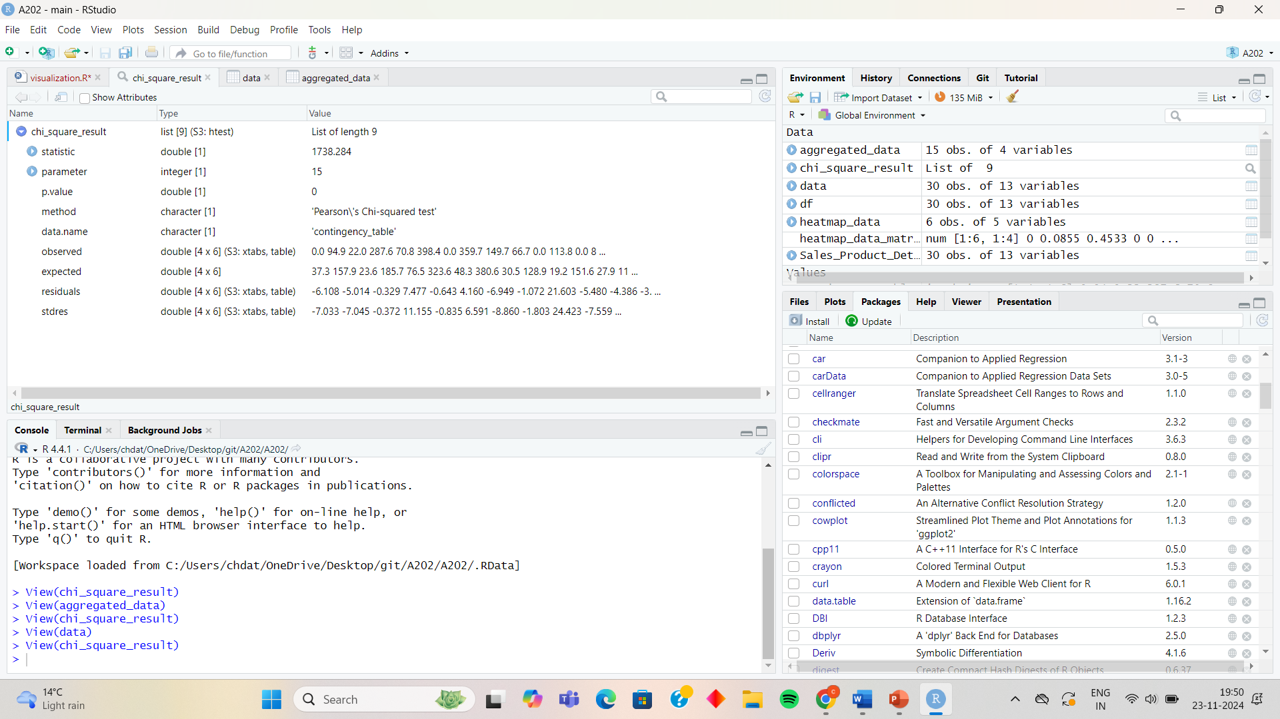

Heat Map Data Matrix

